25.75: a) 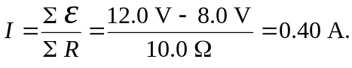
b)
c) Power generated in
d) Rate of electrical energy transferred to chemical energy in
e) Note 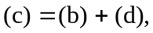 and so the rate of creation of electrical energy equals its rate of dissipation.

